This n That

An e-mail newsletter from Agapé Athletics Club

Editor: Marieta Bortoli 082 466 7031 22 May 2017 www.agape.org.za

E-mail: marietabortoli@gmail.com

NB

- Next league race – Run/Walk for Bibles – 24 June
- Agapé race (Jacaranda City Challenge) – 14 October Members to assist. PLEASE DIARIZE !!!!!!

Editorial

Remember the Comrades Church Services this coming Sunday. I have attached the invite again

Our Comrades tent site number is in tier 4 number 94. See attached site plans

Contents

# Birthday greetings
# Personalia
# Welcome new and former members
# Congratulations
# Thank you’s
# In the mailbox
# General
# Race reports / upcoming race information
# Race results
# Training/Health snippets
# Thought of the week
# Your smile for the week
# Something to ponder over / something spiritual
# AGN league logs
# Races cancelled
# Notice Board
# Photo corner

Notice Board Additions

● Frenus Zietsman Run/Walk against drugs

Attachments

● Comrades Church Service
● Comrades tent site plans

Birthday Greetings
May the Lord bless you and send from above the peace of His presence, the joy of His love. May He grant you happiness in everything you do! Happy birthday!

Dennis Frost 22 May | Rick Sher 23 May
Les Clarke 26 May | Carol de Kiewit 27 May
Charles de Kiewit 27 May | Mavis Stadler 27 May
Pieter Coetzee 28 May | Wilma du Plooy 28 May
Johan Kloppers 29 May

Personalia

Welcome new and former members

Congratulations

Congratulations to the following members:

Thank you’s

In the mailbox

General

Clothing available:
Buffs @ R100
Ladies skirts @ R200
Second skins @ R170

Please contact Marietjie if you wish to purchase some of the items:
Cell: 072 541 7268 E-mail: ventermarix9@gmail.com

The items will also be available at races, please visit our gazebo

Race reports/Upcoming race information

Pick ’n Pay, The Grove, Race for Hope (20 May 2017) - Elbert Loubser
A start at 07:00 did not make things much warmer than what a 06:00 or 06:30 start would have been. Granted, it was a tad warmer than the Love Run of the previous Saturday. Hmmm, one does appreciate those few additional minutes one is able to afford to soak up the cosseting of blankets. By now, I have learnt to have my ‘armour’ all ready when emerging from the cocoon of warmth. Yip, the beanie, giraffe neck, sweat suite top/pants, wind breaker jacket, T-shirt, running vest etcetera, all ready to be donned swiftly. The aim of preventing any unnecessary body temperature drop was successfully accomplished

The 10 kay and 21.1 kay participants were set off, direction South in Equestria Road. Quite appropriate as this is the suburb of Equestria itself. Left in The Hwy street (map says so!), left into Libertas Avenue (slight downward slope), right Griffiths (flat section), right into Meadow (a slight lengthy upward pull), left into Cura, right into Meerlust (nice and flat), loooong stretch on Vergelegen, left into Stellenberg (lovely down section). By now we are ‘out between the plots’, breathing crisp fresh air, experiencing some of the tranquillity which ‘nature’ has to offer. Left into Cura (sounds familiar), right into Furrow on which we pass over Libertas (again familiar), Glen and Ouklipmuur Ave (translation: Old stone wall) and then a drag uphill to Simon Vermooten, bypass Bester Birds and Zoo animal Park, left into Ouklipmuur, right into Ouklipmuur (I kid you not), left into Farm Road (where the 10 kay participants leave us to the right towards the Finish line), we do a return curve on Farm- and Glen Avenues, then are launched back into a ‘blue print’ copy of the first lap up and out via Equestria Ave. Now it became quite ‘lonely’ out there

By now the winter sun is warming up the ambient air, which regular well stocked watering points obliged relief with the ample supply of cold Coke and water sachets. Still bugs me that participants just don’t get it: To pre-empt littering, all one needs to do is throw/put your own ‘used’ empty sachet or paper cup back into a ‘dustbin’ or similar receptacle provided. In actual fact, I noticed there were numerous concrete (advert) dustbins available quite regularly on the pavements, within easy reach. Noticed one participant literally throwing a sachet into a brush, which begs the question: ‘Whom do they think is going to retrieve that sachet out of that brush?!?!?!’ Another question comes to mind: ‘Does throwing a sachet into a drain assist in keeping our environment clean?!?!?!?!’

Once again, thank you to Hennie and Marietjie for pitching the ‘base camp’ gazebos. They arrived quite early to ensure a spot close to the finish line

This was an enjoyable, fairly flattish course, with some ‘out in the country side’ ambience mixed into the recipe. As I understand it, the Sungardens Hospice is thrilled with the amount that was raised on Saturday (snippet provided can be found on Facebook, courtesy of Joan Erasmus): https://www.facebook.com/joan.erasmus.5/posts/10154469079510671

Agapé greetings

Race results
The Love Run - 10km race - 2017-05-13
Position | Initials | Surname | Sex | Age | Finish Time
56 | W | Reinecke | M | 42 | 00:56:25
103 | K | Nurden | M | 82 | 01:02:00
113 | L | Fourie | M | 72 | 01:03:09
151 | H | Venter | M | 57 | 01:07:26
159 | R | Hughes | F | 60 | 01:07:44
255 | D | Frost | M | 60 | 01:15:17
263 | A | Potgieter | F | 45 | 01:15:54
271 | A | Du Plessis | F | 62 | 01:16:20
272 | M | Venter | F | 57 | 01:16:25
414 | M | Reinecke | F | 41 | 01:34:28
The Love Run - 21km race - 2017-05-13
Position | Initials | Surname | Sex | Age | Finish Time
24 | J | Pokwane | M | 45 | 01:30:51
97 | S | Brink | M | 46 | 01:48:41
110 | S | Marais Werner | F | 43 | 01:51:00
183 | M | Van Der Walt | M | 45 | 01:58:54
190 | M | Malan | F | 58 | 01:59:19
195 | C | Burger | M | 52 | 01:59:39
254 | K | Imrie | M | 45 | 02:05:25
257 | K | Kennedy | F | 37 | 02:05:41
269 | A | Marais Werner | F | 43 | 02:06:49
283 | H | Van Schalkwyk |  | 41 | 02:08:32
597 | E | Loubser | M | 60 | 02:57:01

Training/Health snippets

Reduce Shoulder Tension

Upper-body tightness can slow you down
All the hours we spend slumped over a desk can cause tightness in the neck, upper back, and shoulders, which can carry over to running. Holding tension in the upper body is one of the most common problems runners have. When your shoulders inch up toward your ears, it prevents your arms from swinging freely forward and back. Your arms take a less natural side-to-side motion, which is a waste of energy and can cause unnecessary fatigue.
Try this experiment to see what we mean: Hike up your shoulders and hold both your arms slightly outwards. Now stay in that position for five minutes. Tough? Now, imagine staying like that for the duration of an entire race. To unlock your shoulders, we recommend these basics.
If your work requires sitting most off the day then taking mini stretch breaks throughout the day will provide some relief.
Try to keep relative good body posture. Shoulders rounded, head thrust forward is a no! no! we constantly overtax our neck and shoulder muscles.
Consider the following posture to be adjusted while running;
It is recommended you hold your head so your ear sits directly over the middle of your shoulder. This might seem awkward at first, as it will feel too upright. But it's precisely how you should be running.
When you're running, you should be straight up and down. The only time to lean forward is when you're accelerating/falling.
Reach high with the top of your head, don't suck in your stomach and don’t lift your shoulders. Just run tall, and let everything else hang loose.
A few simple routine stretches we can easily straighten ourselves out.

Basic:
Standing flush against a wall, heels, buttocks, back, neck, and head all pressing back. This stretches the muscles and makes it easier to adopt a proper posture. Hold position for 1min but not less than 10 sec. Relax for 20sec and repeats, repetitions as needed.
Neck: Lower your right ear toward your right shoulder. Press gently down on your temple with your fingertips. Hold, release, and repeat 10 times on each side.


Shoulder: Raise your right arm up, keeping your elbow locked and your palm facing forward. Grasp your arm between the elbow and shoulder with your left hand. Pull gently, hold, release, and repeat 10 times on each side.

Get Strong: This move strengthens the rhomboids and the trapezius muscles, which control and stabilize the upper back and shoulders. Do this twice a day to alleviate tension and improve your running form.


1. Let your arms hang relaxed at your sides with palms facing in
2. In one slow, continuous motion, rotate your shoulders upward, backward, downward, and forward, bringing them toward each other. Hold for a second.
3. Do it in reverse, rolling your shoulders until your arms return to the starting position.
4. Do two sets of 10 reps. Hold dumbbells to make it harder.
Throughout your run, try to check your running form to make sure you're not allowing any tension to creep into your run:
Basics: What to do and look for:
Are your shoulders moving up toward your ears? If so, roll your head back, push your shoulder blades together, and let your shoulders drop.

Keep arms at a 90-degree angle:
Are your arms at a 90-degree angle to ground? When runners get tired or tense, their hands start to move up towards their shoulders. If you notice this happening, drop your arms to the sides and shake out your arms. Then re-position them at a 90-degree angle. Repeat as necessary.

Relax your hands and wrist:
Are your hands in a tight fist? If you're clenching your fists, the tension in your hands will move from there up your arms to your shoulders and neck. Try to keep your hands and wrists relaxed. You should keep your hand in a loose fist, almost as if you're holding an egg and you don't want to break it. The key is concentration even when tired.

Keep your arms at your side:

Are your arms crossing over your chest? Your arms should swing at your side and not cross your chest. If you're crossing over your chest, your arms will start moving up toward your shoulders and you'll find yourself hunching over more (which also makes it harder to breathe). Keep your arms at your sides, parallel to each other.

In addition do the following before and/or after a run:
Shoulder shrug: Inhale and lift your shoulders toward your ears, taking three slow count to raise them. Exhale and just let your shoulders fall, giving into gravity. Repeat five times.

Chest opener: Bring your hands to your hips, take a breath in, and, as you exhale, tuck your chin slightly and squeeze your shoulder blades together behind you.

Head tilt: Gently lower your right ear toward your right shoulder and then slowly switch sides. Don't hang in any one position for too long, as this isn't really a stretch — super tense neck muscles don't like to be stretched. Just try to get your stiff, tense neck moving around. Repeat five times on each side.

Head nod: Tuck your chin toward your chest, taking three slow counts to do so. Really isolate the movement so just the neck is moving; don't round the upper back. This move provides a stretch for the muscles in the back of the neck. Then lift your head and lower it behind you, gazing at the ceiling to stretch the throat. Repeat three to five times.

Self-massage: Take your left hand to your right shoulder, tilting your head slightly to the left. Slowly run your fingers along the muscle, giving your shoulder some gentle squeezes. Repeat on the other side.

Your thought for the week

Appreciate those who love you, help those who need you, forgive those who hurt you and forget those who leave you!

Your smile for the week
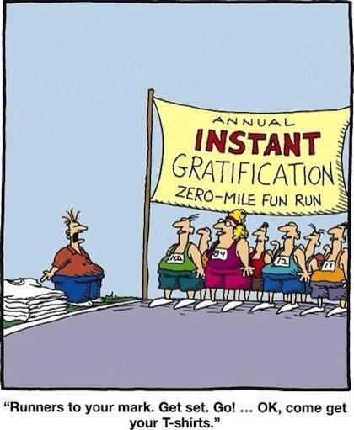

Something to ponder over / something spiritual
HET JY GEWEET?
In die konsentrasiekamp, meer as 100 jaar gelede, sit Annette Marais op ’n stomp en skud die stof van haar verslete klere af.
Rondom haar sit die groepie bekende gesigte van moeë vrouens. Net ’n paar tree verder is die hoë draad van die konsentrasie kamp. Sy slaan haar Bybel oop en begin lees. Sy het in die donker ure van die nag geworstel met God en Hom gesmeek vir ŉ boodskap om hierdie vrouens te bemoedig, want wie weet hoe lank nog . ... ..
Annette lees die woorde van Matt 10:29 – “Is twee mossies nie vir ’n sent te koop nie, en tog sal nie een van hulle op die grond val sonder die wil van julle Vader nie.”
Terwyl sy besig is om hierdie woorde te lees, kom sit daar ’n vaal klein mossie op haar skouer.
Die groepie vrouens staar in verbasing na wat voor hulle gebeur, en so word die mossie, die teken van hoop in die onmoontlike omstandighede van die konsentrasie kamp in Bethulie.
Dit was fantasties om in die maande wat volg te sien hoe die mossies van Bethulie ’n baken van geloof en hoop word vir hierdie vrouens.
Op 21 Mei 1902 was die oorlog verby, Annette het op pad terug na haar huis gestop by ’n vrou met invloed en haar vertel van die mossie-boodskap, sy het dit weer oorvertel en Genl Jan Smuts het in 1923 die mossie op die land se kleinste muntstuk (kwartpennie) laat verskyn.
Amper 80 jaar later sit Jak de Priester in ’n park in Londen. Sy geld is op, hy kry nie werk nie, hy mis die meisie van sy drome en sonskyn en biltong. Hy slaan sy klein silwer Bybeltjie oop en lees die “mossie” boodskap en bid vir die soveelste keer vir werk!
Vroeg die volgende oggend lui sy telefoon en dis die oproep waarvoor hy gewag het, hy spring op die eerste trein en begin met ŉ lang dag se onderhoude. Moeg maar gelukkig en met ’n permanente werk klim hy weer laatmiddag op die trein.
Toe hy inklim sien hy ’n muntstuk op die vloer lê, hy tel dit op, en daar op ’n trein in Londen hou hy ’n Suid-Afrikaanse 1c in sy hand, met ’n mossie agter op. Hy vertel dat die wêreld rondom hom gaan stil staan het, dat hy besef het dat God daar by hom op die trein is en dat gebed sy waarborg is in hierdie stukkende wêreld.
Vandag ’n paar jaar later, skud ek my beursie uit. Ek sit ŉ 1c neer vir my vriendin met borskanker, nog ŉ 1c vir huwelike wat sukkel, ’n 1c vir iemand na aan my hart se werksomstandighede, vir enkel ouers en weduwees, en ek besef die mossie boodskap is dalk net een versie in ’n dik Bybel, maar ’n Almagtige, liefdevolle God staan agter dit!
Here, dankie, dat daar altyd hoop is. Dankie, vir bakens langs die pad wat ons help om geduldig te wees, terwyl ons wag vir U, om op die perfekte tyd ons omstandighede te verander. Gister terwyl ek vir my kliente sit en wag en ek dieselfde boodskap vir my vrou gestuur het, het 3 mossies op my voertuig se voorste "bushbar" kom sit en het ek dadelik geweet ons Koning praat met my om my gerus te stel. Daar is niemand soos Hy nie en Hy sal altyd na ons kyk en ons versorg. Hy's net 'n gebed ver. Geseënde "mossie" dag vir jou.
Mag God Homself ook vandag op ‘n besonderse manier aan jou openbaar.
League results

Cancelled Races

The Green Mile AC has cancelled their race that was scheduled for Friday, 16 June (public holiday).

Notice Board

Useful Links:
www.raceresults.co.za/flyers - for the latest race pamphlets
www.agn.co.za/#League for the latest league logs and the league points you earned
http://www.agn.co.za/Docs/2016/WAlking/AGN%20road%20walking%20stds%20ref%20685.pdf
AGN 2016 RW qualifying standards and selection criteria
www.runawaysport.co.za Run-A-Way Sport’s web site
www.verticalhorison.co.za Trail Running www.trailseries.co.za Trail Running
http://www.mastersathletics.net/Age-Graded-Calculator.2595.0.html Age Graded Calculator
http://www.sportsinjuryclinic.net/symptom-checker By clicking where it hurts then ticking which symptoms most apply to you we can give you an indication of what injuries may apply.

Saturday 27 May Superspar Hercules Skosana Legend 10/5 km run/walk
Race Organisers: Run/Walk for Life
Venue: Superspar, Moort Street, Hercules, Pretoria

 | 10 km | 5 km
Entry-fee | R 60 | R 40
Start Time | 07:00
Cut-off | ??:00

Pre-entries at: Run-away Sport; The Runners Store Tramshed; Hercules Superspar

www.enteronline.co.za

Saturday 3 June Race of Faith 5.20/10.23/14.87 km
Race Organisers: Run/Walk for Life
Venue: Silver Oaks Crossing; c/o von Backstrom Boulevard & Solomon Mahlangu Drive, Willow Acres
GPS: S 25 45 57.57 E 28 21 31.80

 | 14.87 km | 10.23 km | 5.20 km
Entry-fee | R 60 | R 50 | R 40
Start Time | 07:00 |  | 07:10
Cut-off | ??:00

Only the 5.20 km race is suitable for wheelchair athletes

No dogs allowed

Pre-entries at: Run-away Sport; The Runners Store

Saturday 10 June Frenus Zietsman Run/Walk against drugs 10 / 5 km
Race Organisers: Mamelodi Athletics Club supported by Run/Walk for Life
Venue: Ninapark Spar, c/o Brits & Grafenheim Street, Nina Park

 | 10 km | 5 km
Entry-fee | R 70 | R 40
Start Time | 07:30
Cut-off | ??:00

Wheelchair athletes welcome

No dogs allowed
Pre-entries at: Run-away Sport; The Runners Store Tramshed; Ninapark Spar

www.entrytime.com

2017 AGN LEAGUE FIXTURE LIST
EVENT | DISTANCE | DATE | LEAGUE
 |  |  | RR | RW
Run/Walk for Bibles | 10 / 21.1 km | 24/06/17 | X | X
Long Walk/Run for Freedom | 10 / 21.1 km | 22/07/17 | X | X
Marcel van’t Slot | 15 km | 19/08/17 | X | X
Addicted to Life | 10 / 21.1 km | 09/09/17 | X | X
Jacaranda Challenge | 10 / 21.1 / 42.2 km | 14/10/17 | X | X
Kolonnade Retail Park | 10 / 21.1 km | 11/11/17 | X | X

Masters Athletics Fixture list

Local meetings
12 August 2017 Claude Sterley memorial masters meeting Pilditch
? Sept/? October 2017 SWD Oudtshoorn
11 November 2017 Free State Bloemfontein

African Masters Track & Field Championship
27 – 29 May 2017 Cameroon
Time Trials:

Centurion -
Lewende Woord Centurion on Wednesdays at 17:15
Contact Marinda 654 5800 (h) 082 720 9017

Rietondale –
North Street, Rietondale (Rietondale Park in the street before the Crawford Stadium) Thursdays 17:30
Contact Dorothy Benadie 082 704 2300 dorothy.benadie@gmail.com or
Hennie Venter 083 702 4472

Zita Park - Tuesdays at 17:30
Zita Street, Zita Park, Garsfontein
Contact Hennie Venter – 083 702 4472 Marietjie Venter – 072 541 7268

Gazebo Enquiries

Hennie Venter – 083 702 4472 Marietjie Venter – 072 541 7268

Intercessor:

Fred Harding 076 777 7786 

Agapé Executive 2016/2017

Name | Position | Telephone number | E-mail address
Marieta Bortoli | Chairperson & editor | 012 331 2089  082 466 7031 | marietabortoli@gmail.com
Hennie Venter | Registrar & club captain | 083 702 4472 | henniev@seng.co.za  join@agape.org.za
Marilett Jenkins | Secretary | 082 837 2142 | marilett.jenkins@mervitzmalan.co.za
André Breytenbach | Treasurer | 083 566 1090 | andreb@geoscience.org.za
De Wet de Beer | PRO & vice-chairman | 082 373 2987 | dewet@styletechnique.co.za
Kobus Stander | Race organiser | 082 688 6697 | CLK1560PHARM@clicks.co.za
Fred Harding | Intercessor | 076 777 7786 | fredharding@telkomsa.net
Marietjie Venter | General activities & clothing co-ordinator | 072 541 7268 | Ventermarix9@gmail.com
Gustav Brink | Statistician | 083 417 8431 | gustav.brink@gmail.com

Photo corner

Agapé Executive

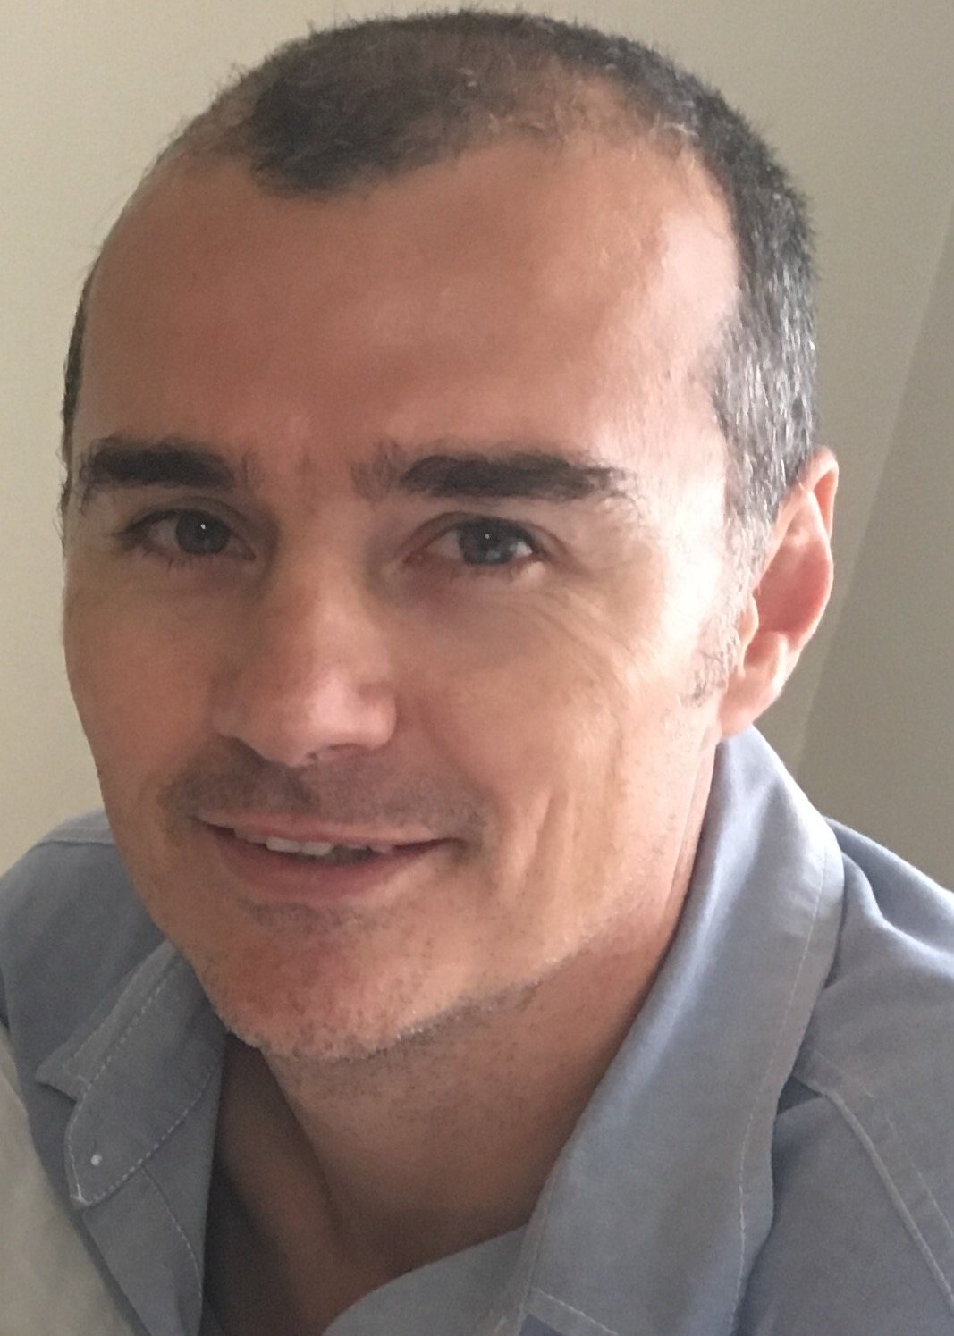

Marieta Bortoli Marilett Jenkins De Wet de Beer

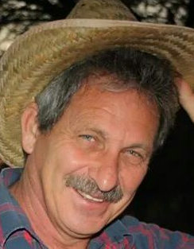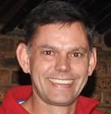
Hennie Venter André Breytenbach Kobus Stander

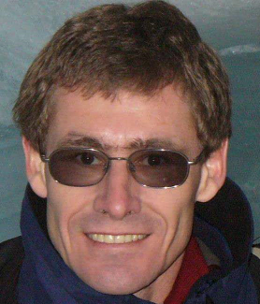
Marix Venter Fred Harding Gustav Brink (Ex-officio)

Photos taken at the Grove race

